Example of Hub and Spoke Model for Economic Development—Burlington Bread

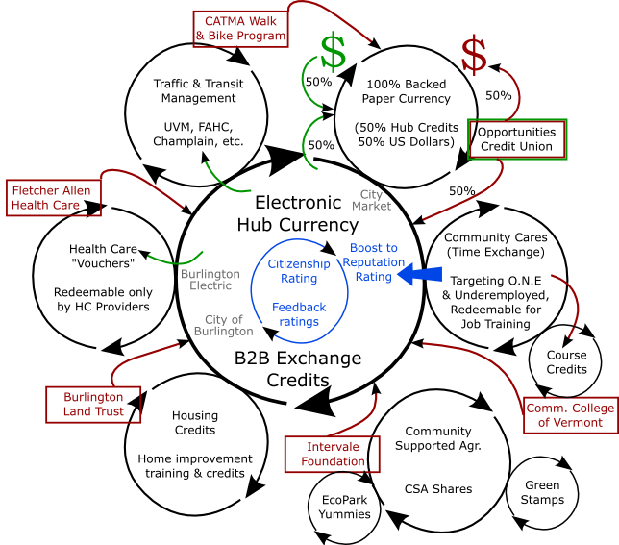

Some questions to explore:
- What is a community specifically trying to accomplish? What problems are they trying to solve? What needs are they trying to address?
- What are the general advantages to localizing a currency?
- Why use a generalized B2B exchange as a hub? Why not?
- Why use targeted spoke currencies?
- Why can’t the hub currency solve/address all needs?
- How can we service the retail sector with minimal complexity?
  - Swipe cards? Smart cards? IVR? Paper bills? Etc…
- How can we reach across the digital divide and include people with little technology access?
- What are the best ways to make a paper currency work?
  - Is backing necessary? What can be used to back a paper currency? Examine some alternatives?
    - No backing
    - Partial backing
    - Fully backed
      - 100% Cash
      - 100% Other credits
      - Blend of each
  - What are the strategic advantages for each type of participant (businesses, employees, banks, customers/consumers, city, etc.)
  - How can we manage issuance?
  - How do you minimize risk of counterfeiting?
- Is every spoke currency exchangeable with the hub?
How do reputation currencies integrate with this model?

